|  |
| --- |
| MINI PROJECT  (2020-21)  “**QUIZOPHILE QUIZ APP”**  Project Report    **Institute of Engineering & Technology**  Submitted By -  Garima Rajpoot (201599011)  Swati Gupta (201599029)  Shweta Singh(191500808)  RadhikaSrinivasanIyengar (201599021)  **Under the Supervision Of**  **Mr. Mohd. Amir Khan Sir**  **Technical Trainer**  **Department of Computer Engineering & Applications** |

**Department of Computer Engineering and Applications**



**GLA University, 17 km. Stone NH#2, Mathura-Delhi Road,**

**Chaumuha, Mathura – 281406 U.P (India)**

# Declaration

I/we hereby declare that the work which is being presented in the Bachelor of technology. Project **“Quizophile Quiz App”**, in partial fulfillment of the requirements for the award of the ***Bachelor of Technology*** in Computer Science and Engineering and submitted to the Department of Computer Engineering and Applications of GLA University, Mathura, is an authentic record of my/our own work carried under the supervision of **Mr. Mohd Amir Khan, Technical Trainer, Dept. of CEA,GLA**

**University.**

The contents of this project report, in full or in parts, have not been submitted to any other Institute or University for the award of any degree.

|  |  |  |
| --- | --- | --- |
| **Sign**: Garima Rajpoot |  | **Sign**: SwatiGupta |
| **Name of Candidate**: GarimaRajpoot |  | **Name of Candidate**: Swati Gupta |
| **University Roll No**.:201599011 |  | **University Roll No**.: 201599029 |
| **Sign:** RadhikaSrinivasan |  |  |
| **Name of Candidate:** Radhika Srinivasan Iyengar |  |  |
| **University Roll No**.:201599021  **Sign:** ShwetaSingh  **Name of Candidate**: Shweta Singh  **University Roll No:** 191500808 |  |  |

**Department of Computer Engineering and Applications**

**GLA University, 17 km. Stone NH#2, Mathura-Delhi Road,**

**Chaumuha, Mathura – 281406 U.P (India)**

# Certificate

This is to certify that the project entitled “Quizophile Quiz App”, carried out in Mini Project – I Lab, is a bonafide work by Garima Rajpoot, Swati Gupta, Shweta Singh, and Radhika Srinivasan Iyengar is submitted in partial fulfillment of the requirements for the award of the degree Bachelor of Technology (Computer Science & Engineering).

**Signature of Supervisor:**

**Name of Supervisor:** Mr. Mohd. Amir Khan **Date:**

**Training Certificate**

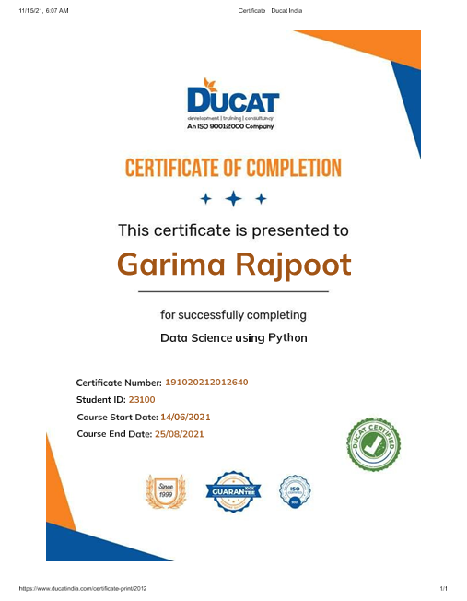

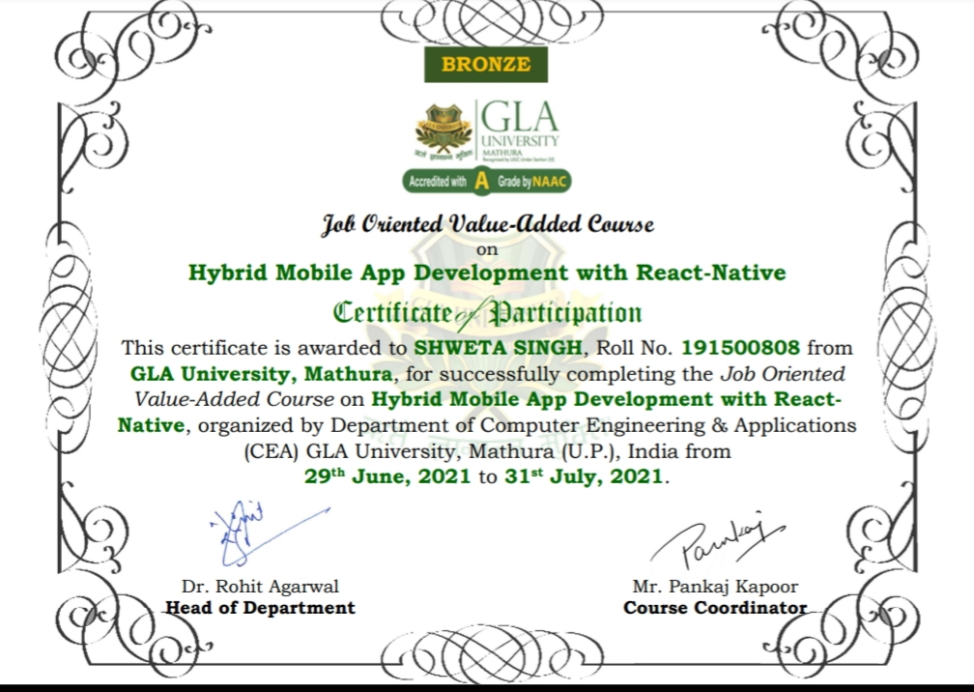

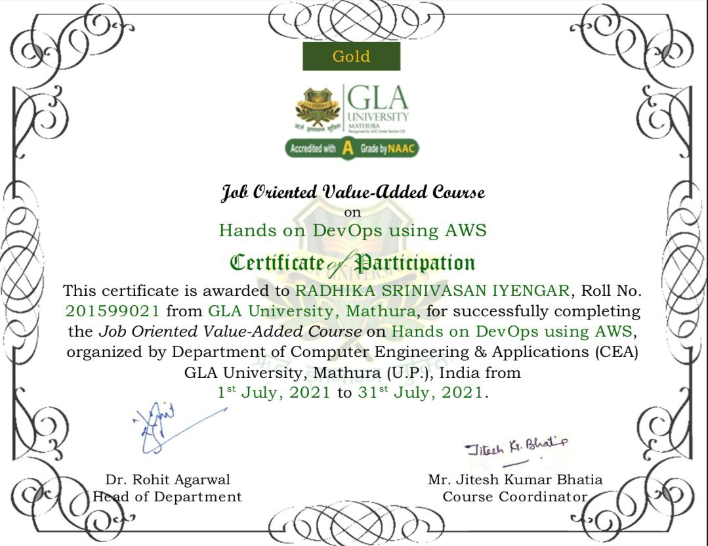

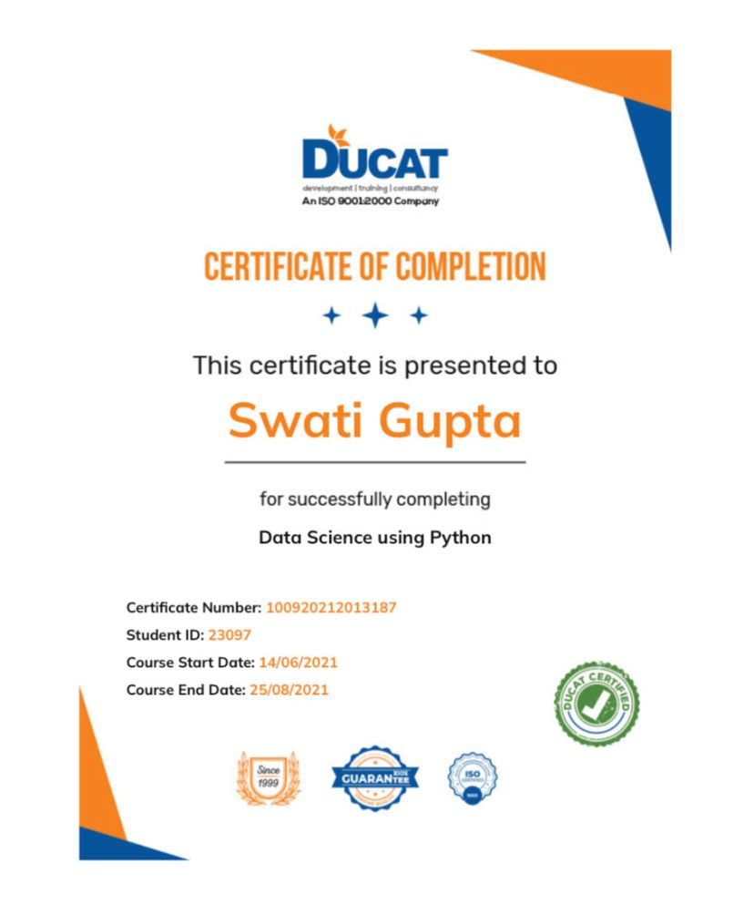

**Department of Computer Engineering and Applications**



**GLA University, 17 km. Stone NH#2, Mathura-Delhi Road,**

**Chaumuha, Mathura – 281406 U.P (India)**

# ACKNOWLEDGEMENT

Presenting the ascribed project paper report in this very simple and official form, we would like to place my deep gratitude to GLA University for providing us the instructor Mr. Mohd. Amir Khan Sir, our technical trainer and supervisor.

He has been helping us since Day 1 in this project. He provided us with the improvements we can do in our project, the basic guidelines explaining on how to work on the project. He has been conducting regular meeting to check the progress of the project and providing us with the resources related to the project. Without his help, we wouldn’t have been able to complete this project.

And at last but not the least we would like to thank our dear parents for helping us to grab this opportunity to get trained and also my colleagues who helped me find resources during the training.

### Thanking You

**Sign**: *GarimaRajpoot* **Sign**: *RadhikaSrinivasan*

**Name of Candidate**: Garima Rajpoot **Name of Candidate**: Radhika Srinivasan Iyengar

**University Roll No**.:201599011 **University Roll No**.:201599021

**Sign:** *ShwetaSingh* **Sign**: *SwatiGupta*

**Name of Candidate:** Shweta Singh **Name of Candidate**: Swati Gupta

**UniversityRoll No**.:191500808 **University Roll No**.:201599029

# ABSTRACT

In this project, we are creating a python application, basically a Quiz App which we have named Quizophile. The project: “Python quiz App” is the collection of questions based on python. There will be limited number of questions and for each correct answer user will get a credit score. There are many quiz applications available currently on internet. But there are few which provide better understanding between users and the application like, providing proper answer, solving user query, uploading user application as well as answer to it, etc. This Application provides many functionalities to the user like, various topics for practicing quizzes, Evaluating the answers without manual assistance, analyzing the reports for the users, suggestion of other related quizzes for their improvement, involving guardians by sending them the result of their children and many more. It also provides ease to the examiner by providing the functionality of OCR Scanning.They can easily access the data whenever and wherever they want without any manual need and prepare the questions. The examiner can also see the result of the user so as to know their progress and help them in their improvements. Also, the system will itself suggest some books and resources sites to the users subjectively to help the users improve themselves more.

## CONTENTS

CoverPage……………………………………………………………………..i Declaration ……………………………………………………………………ii

Certificate ……………………………………………………………………..iii

Training Certificate………………………………………………..………….iv

Acknowledgement ………………………………………………………….vii Abstract ……………………………………………………………………..viii

Content …………………………………………………………………….….ix

List Of figures ………………………………………………………………….xi

List Of tables ………………………………………………………………..xii

Chapter 1Introduction……………………………………..……..………………1

* 1.1 Context………………………………………………………………...1 •1.2 Motivation…………………………………………………………......1 •1.3 Objective……………………………………………………………….2
* 1.4 Existing System……………………………………………………......2 •1.4 Sources…………………………………………………………………3

Chapter 2 Software Requirement Analysis…………………………………….....4

* 2.1 Impact Of Books On Daily Life ……………..……………………….....4
* 2.2 Problem Statement……………………………………………………..5
* 2.3 Hardware and Software Requirements…………….…………………...6
* 2.4 Modules and Functionalities………………………….………………..6
* 2.5 quiz application on Android……………,,,,,,…………………7 Chapter 3 Software Design………………………………………………………..8
* 3.1 Use Case Diagram………………………………………………….…..8
* 3.2 Data Flow Diagram…………………………………………….………11
* 3.3 Sequence Diagram……………………………………………..……….12

Chapter 4 Technology Used………………………………………………………13

* 4.1IDLE(python)……………………………………………………………...….13
* 4.2 Version of Python……………………………………………………..14
* 4.3 Tools and Languages………………………………………...…………15
* 4.4 Basic Terminology……………………………………………………..16

Chapter 5 Implementation and User Interface…………………………………….19

* 5.1 Implementation of quizophile…………………………………...……19
* 5.2 User Interface…………………………………………………………..23

Chapter 6 Testing…………………………………………………………….……33

* 6.1 Installation Testing…………………………………………….……….33 •6.2 Unit Testing…………………………………………………….………34
* 6.3 User Testing……………………………………………………………37 •6.4 Performance Testing…………………………………………..……… 38 •6.5 Compatibility Testing………………………………………...………. 39

Chapter 7 Conclusion……………………………………………………………40

**References***……………………………………………………….……………………….41*

# LIST OF FIGURES

1. Existing System……………………………………………………………2
2. Use Case Diagram…………………………………………………………9
3. Data Flow Diagram………………………………………………………..11
4. Sequence Diagram…………………………………………………………12
5. Android Kit-Kat……………………………………………………………14
6. Flow Chart for User………………………………………………………..21
7. Splash Screen………………………………………………………………23
8. Register Page………………………………………………………………23
9. Login Page…………………………………………………………………24
10. Forget Password…………………………………………………………...24
11. Navigation Drawer………………………………………………………...25
12. Dashboard Fragment………………………………………………………26
13. Profile Page...……………………………………………………………...27
14. Favourite Page……………………………………………………………..28
15. Sign-out Page…..…………………………………………………………..28
16. About App Page……………………………………………………………29
17. FAQ Page…………………………………………………………………..29
18. Search Page…………………………………………………………. 30
19. Description Page……………………………………………….…………. 30

# LIST OF TABLES

1. Version of Android…………………………………………………………14
2. Unit testing of Bookopedia……………………………………….………..34

CHAPTER-1

INTRODUCTION

### 1.1CONTEXT

This python Application “Quizophile” has been submitted in partial fulfilment of the requirements for the award of the degree of Bachelor of Technology in Computer Science and Engineering at GLA University, Mathura supervised by Mr.MohdAmir Khan. This project has been completed approximately two months and has been executed in modules, meetings have been organized to check the progress of the work and for further instructions and guidelines.

### 1.2MOTIVATION

In the recent years, we have realized the importance of virtual learning and how important it is for us to have our resources online. Internet and the rising technologies has given a huge rise in the field of education.

In the century we are living the world is progressing at a really great pace, a lot number of technologies come up every single day. To keep up with the technology is also important to survive in this world of digitalization and learning. Along with this we also need a place to assess our level of knowledge and for this purpose we decided to develop a quiz application which will help us to assess our knowledge and skills. Its features will help the examiners and also the parents to make the student grow in the particular field.

Moreover this kind of application can be used in areas/schools where guardians /parents cannot only be included to see the growth of the children in studies but can also be included to see their results. This would be an excellent effort to provide improved education without any boundaries to all.

### 1.3OBJECTIVE

The main objective of this application is to create a Quiz app named “Quizophile” which will have a lot of subjects on which a user can perform quiz exams on and improve themselves in that particular field. The main advantage of this app is that it can be used anywhere only with a help of a device and internet, no need to carry anything else. This app also reduces the manual efforts made by the faculties to print question papers for the assessment. It can be now easily done with the help of this app. It also contains OCR which eases out the efforts of typing the questions.

This application developed can be used at a variety of places, at education hubs and have its significance. The goal of the app was to provide a way to the learners and users to get all the knowledge easily they desire to get into themselves.

### 1.4EXISTING SYSTEM

In the present scenario, the quiz applications are only capable of displaying the questions, and correcting the answers on the basis of input given. It made difficult for the regular users to gather their result from different subjects and analyze them to know their improvements. The faculties also had to give their much time in order to design the quiz by preparing the questions. But, OCR included in this app helps the faculties to reduce their effort. Even in the existing system, we can see that the

But this App tends to solve all the problems and make the quiz more interesting and easier to use.

.

### 1.5SOURCES

The source of our project (including all the project work, documentations and presentations) will is available at the following link [https://github.com/JanviPangoriya/Book_finder_app_mini_project.](https://github.com/JanviPangoriya/Book_finder_app_mini_project)

**CHAPTER -2**

**SOFTWARE REQUIREMENT ANALYSIS**

## 2.1 IMPACT OF QUIZ ON DAILY LIFE

In the world of education there are many different ways to teach and to consolidate what has been learned. In years gone by, children were expected to memorize dates, formulae and figures by rote. But this method of teaching can be quite dull, to say the least! One tool becoming more common, especially in online education, is quizzes. In this guide we’ll find out the many reasons why quizzes are valuable in learning.

With quizzes so popular, is there any evidence to suggest that they really are valuable in a child’s education? Well, yes – ask any teacher! In classrooms up and down the land teachers set their students tests and quizzes to help them learn. All those teachers can’t be wrong! The value of tests and quizzes is unquestionable.

When you’re playing a quiz you have to keep your mind on what you are doing. This means that quizzes do help children concentrate. Reading from textbooks often fails to grab our attention. The mind wanders and information is not taken in.

It’s a well-known fact that retrieval aids retention. Reading information as a way of learning does have its uses. But reading information and then taking a quiz is much more effective. Forcing your brain to retrieve data ensures that it becomes ‘embedded’ for use in the future. So, yes, quizzes do help us retain information.

As quizzes help to embed information in our brains, this provides a firm foundation for the next stage of learning. Take maths as an example – once something is mastered by making use of quizzes (methods of multiplication say) then this will help to support any future, more advanced learning (like algebra). Quizzes can help to prepare children for the next stage in their education and help the learning process.

Imagine, the first time you play a quiz you get 4 out of 10 right. So, you try to remember the answers and play it again. This time you get 8 out of 10. The more often you play quizzes the better you get at them and the more you know. Looking back over online quiz records and seeing how much they’ve improved, gives a student the confidence to know they are progressing. So, yes, quizzes do build confidence.

Few of us enjoy exams but, like it or not, they’re here to stay. To prepare for exams it’s good to test yourself on the subject. The more students play quizzes the better equipped they become for quickly recalling the information required to answer examination questions. Another yes - quizzes can prepare children for exams.

## 2.2 PROBLEM STATEMENT

The project requires an efficient quizzing system to access the students of third year IT based on the skills in various subjects. It generates report of all the students who taken up the test and stores it for future use. Access rights are allocated in following order.

Administrator->Professors/H.O.D->Students The administrator is given rights only to add or delete student profiles. But has no rights to access the quizzing information. Professors and lecturers are given rights to access the question available and if needed, make changes to them. They can also access the report database to view the overall and individual performance of the students and then take the necessary action. All the reports and queries are at their disposal.

Students are the end users of the system. They attend the quizzing sessionand their marks are added to the database final reporting is done based on theirperformances. The student cannot access any of the databases including thequestions, report or the profile database. Each student is given a username andpassword to ensure the security.

The quizzing system is basically objective and all the questions are related tothe course subject offered for that year. The session is fixed for each student andthe questions carry a time limit within which the students are supposed to answerthe questions. Otherwise the question lapses and no points are awarded for thatquestion. The student has the ability to pass the question and answer the questionlater within the remaining time left.

The quiz program enables us to save time on assessment. It also providesinstant results to the users. The assessment provided by the system is accurate andhelps the professors to decide the further course of action. It is also very efficientas there is no manual intervention.

## 2.3 HARDWARE AND SOFTWARE REQUIREMENTS

**Hardware Requirement**

* Processor :intel i5
* Operating System :Any Operating System
* RAM : 8 GB (or higher)
* Hard disk : 256GB

**Software Requirement**

* Software used: IDLE (Python)
* Language used : Python
* Database: MYSQL
* User Interface Design : Python

**2.4 MODULES AND FUNCTIONALITIES**

* + - **Splash Screen**: The first screen with which the user interacts will be this screen containing the logo and the app name .
    - **Login Page**: This page is for those users who have already registered themselves on the app and have a username and a password. There is also a way on this page for the new users to register themselves which will take them to the registration page.
    - **Registration Page:** This is page is solely designed for the new users of the app who are willing to register themselves. This page takes input of the various details of the user and stores it in the database, later helping the user to login into the account with credentials they have provided.
    - **Forget Password Page:** This page comes into picture when one of the user forgets the login credentials. In this case this page asks for the email-id with which the user has already registered. The app will check if there is any entry in its database with the id and if there a mail will be sent to the same id for recovering the credentials and notification will be given to the user.
    - **Navigation Drawer**: This is the most important part of the application that provides interactivity within the app as it connects the various activities together like it is a side bar on which the profile, the dashboard, the favourites section, the FAQ section ,the About page of the page are linked and on clicking on each you can visit the pages.
    - **Profile**: This page will contain all the user details that the user entered while creating the account on the app. The user can update and make changes to all this information as desired.
    - **FAQ Pages:** This page contains some of the questions that might arise in the mind of the users while using the app and to answer those, these answers are pre-written.
    - **Logout page**: Then is this last panel for the users to sign out from the account. As soon as the users sign out they are brought back to the login page.

## 2.5 QUIZOPHILE ON ANDROID APPLICATION

Quizophile is a python- based application, and enables the user to undertake a series of questions on Java language. The app is user friendly, and the user shall find it extremely easy to answer the multiple-choice questions. At the end of the quiz, a result-report is generated which states the score. The app also presents an option to the current user to play the question-round again or quit in between.

There are three Activities in the app :

1. **Main** – displays Home Screen of application.
2. **Questions** – displays MCQ’s and currents Score.
3. **Results –** displays Results after finishing the quiz.

## SOFTWARE DESIGN

**Chapter 3**

**3.1 USE-CASE DIAGRAM:** 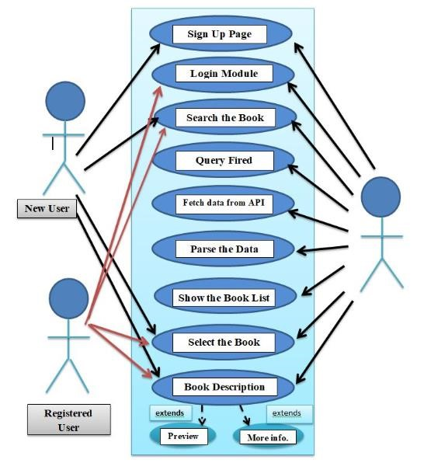

So the above diagram represents the point of view of the new user, the registered user, and the developer and the arrows to each module show the interactivity of the person.

The New user will first be required to create up a new account so will interact with the “sign-up module” and fill up all the details that will be stored in the database. The next user will land into the dashboard where there will be “search bar” where the user can enter the book he desires to read or any related keyword to the book. The list of book will appear on the screen and the new user will interact with “select the book” module. Then the user can interact with the “Description of the Book” module to read more about the book.

For the registered user, the user will be having the credentials to login and will interact with the “login module” and then the user will enter into the dashboard where there will be “search bar” where the user can enter the book he desires to read or any related keyword to the book. The list of book will appear on the screen and the new user will interact with “select the book” module.

Then the user can interact with the “Description of the Book” module to read more about the book.

For the developer he can connect with each and every module mentioned in the use case diagram. Apart from the modules mentioned in use case diagram there are modules like profile, sign out, FAQ and about us section that every registered user can access.

### 3.2 DATA FLOW DIAGRAM

The book list details contain the author name, the book poster, the book genre, and a short review about the book, the price of the book and the link to buy the book. The plus point of this app is it is connected to the Google book API so as soon as a new book is published; it is automatically to the app also.

As soon as the user encounters with the login module, we check the credentials of the user if the credentials are correct as per the database we proceed to the dashboard else if wrong we encounter the forget password module and then mail is sent to the registered mail id. From the dashboard module, we can interact with the favourites section, the profile module, the FAQ Section, The sign out section. On searching the book, from the dash board module, we encounter the check book list activity, checking the book details activity and the published date activity.

The DFD for the Bookopedia is shown below:

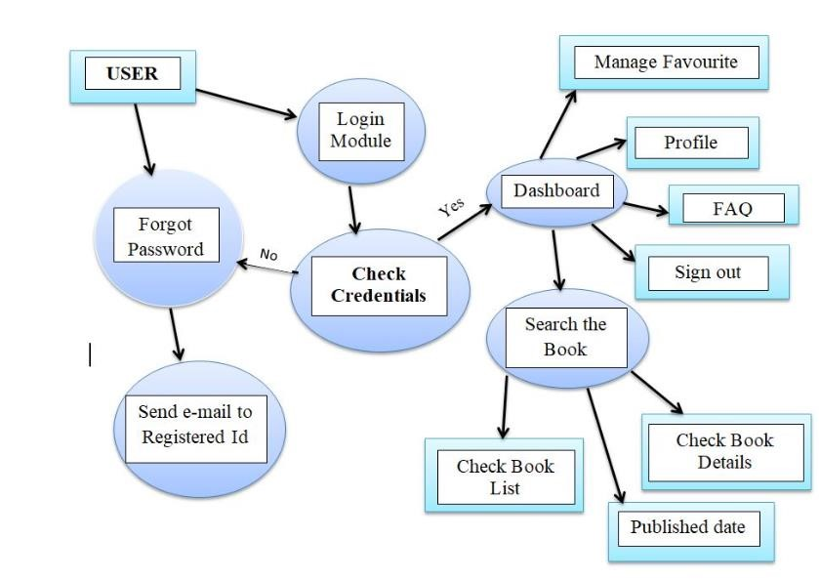

**Figure-3: Data Flow Diagram**

### 3.3 SEQUENCE DIAGRAM

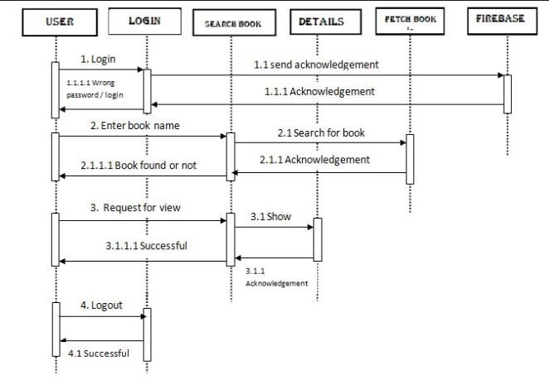

**Figure-4: Sequence Diagram**

## CHAPTER-4 TECHNOLOGY USED

### 4.1PYTHON

Python is a general-purpose interpreted, interactive, object-oriented, and high-level programming language. It was created by Guido van Rossum during 1985- 1990. Like Perl, Python source code is also available under the GNU General Public License (GPL).Python is a high-level, interpreted, interactive and object-oriented scripting language. Python is designed to be highly readable. It uses English keywords frequently where as other languages use punctuation, and it has fewer syntactical constructions than other languages.

Python is a MUST for students and working professionals to become a great Software Engineer specially when they are working in Web Development Domain.

But first it would be great to see the featuresof Python:-

* It supports functional and structured programming methods as well as OOP.
* It can be used as a scripting language or can be compiled to byte-code for building large applications.
* It provides very high-level dynamic data types and supports dynamic type checking.
* It supports automatic garbage collection.
* It can be easily integrated with C, C++, COM, ActiveX, CORBA, and Java.

### 4.2VERSION OF PYTHON

Each year Python releases a new version with better features, better security and better User Interface experience. Here is the table of list of versions.

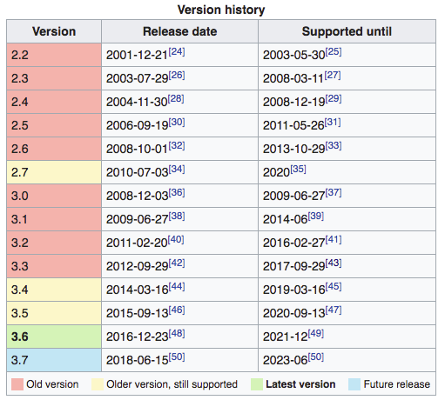

**Table -1: Versions of Python**

#### 4.3TOOLS AND LANGUAGES

Tools used to build the Android App are:-

* **IDLE (Python)**: Every Python installation comes with an Integrated Development and Learning Environment, which you’ll see shortened to IDLE or even IDE. These are a class of applications that help you write code more efficiently. While there are many IDEs for you to choose from, Python IDLE is very bare-bones, which makes it the perfect tool for a beginning programmer.
* Python IDLE comes included in Python installations on Windows and Mac. If you’re a Linux user, then you should be able to find and download Python IDLE using your package manager. Once you’ve installed it, you can then use Python IDLE as an interactive interpreter or as a file editor.
* **Python:** Python is a general-purpose interpreted, interactive, object-oriented, and high-level programming language. It was created by Guido van Rossum during 1985- 1990. Like Perl, Python source code is also available under the GNU General Public License (GPL).Python is a high-level, interpreted, interactive and object-oriented scripting language. Python is designed to be highly readable. It uses English keywords frequently where as other languages use punctuation, and it has fewer syntactical constructions than other languages.

#### 4.4 BASIC TERMINOLOGY

* **Layout:** Layout is the parent of view. It arranges all the views in a proper manner on the screen.
* **Activity**: An activity can be referred as your device’s screen which you see. User can place UI elements in any order in the created window of user’s choice.
* **View**: A view is an UI which occupies rectangular area on the screen to draw and handle user events.
* **Emulator**: An emulator is an Android virtual device through which you can select the target Android version or platform to run and test your developed application.
* **Manifest file**: Manifest file acts as a metadata for every application. This file contains all the essential information about the application like app icon, app name, launcher activity, and required permissions etc.
* **API:** Short for Application Programming Interface. APIs are functions that developers can call on to access specific features by calling upon programs, code, and services that others have written. For example, if a developer wants to draw a button on the screen, she can insert a small bit of code that says “draw this kind of button, with this color and size and style, at this location” instead of dozens of lines of code that tells the graphics processor, in detail, exactly how to draw a button. If the application wants your location, it can use the location API to “get the device’s location” and let Google’s code handle the rest, instead of requiring the developer to build an entire location service from scratch just for her own app. There are thousands of APIs in Android, covering everything from drawing interface elements, to the cameras, to location access, to accessing storage, to 3D graphics (see: OpenGL ES) and much more.
* **Intent:**Intents are an essential part of the Android ecosystem. They are used to express an action to be performed. Intents allow you to interact with components from the same applications as well as with components contributed by other applications. It can be classified into implicit and explicit intents.
* **Implicit intent:** It does not name a specific component, but instead declare a general action to perform, which allows a component from another app to handle it.
* **Explicit Intent:** It specifies the component to start by name. You’ll typically use an explicit intent to start a component in your own app, because you know the class name of the activity or service you want to start.
* **APK**: Short for "Android application package." The extension used in Android app installation files (e.g., app.apk). Similar in nature to an EXE file on Windows.
* **SDK:**Short for "Software Development Kit." As it pertains to Android, the SDK is a set of tools such as code libraries, a debugger, and a handset emulator that can be run on Windows, Mac, or Linux to facilitate the creation of Android apps by developers. While the SDK is generally intended for use by developers, end users can install the software on their home computer to execute ADB and Fast boot commands.
* **Action Bar**: The action bar is an important design element, usually at the top of each screen in an app that provides a consistent familiar look between Android apps. It is used to provide better user interaction and experience by supporting easy navigation through tabs and drop-down lists.
* **Navigation bar**: Android Navigation Drawer is a sliding left menu that is used to display the important links in the application. Navigation drawer makes it easy to navigate to and fro between those links. It’s not visible by default and it needs to opened either by sliding from left or clicking its icon in the Action Bar.
* **Fragment**: A Fragment represents a behavior or a portion of user interface in a Fragment Activity. You can combine multiple fragments in a single activity to build a multi-pane UI and reuse a fragment in multiple activities.
* **Firebase** is a Backend-as-a-Service (Baas). It provides developers with a variety of tools and services to help them develop quality apps, grow their user base, and earn profit. It is built on Google's infrastructure. Firebase is categorized as a NoSQL database program, which stores data in JSON-like documents. Firebase has three core services: a real-time database, user authentication and hosting. With the Firebase iOS SDK, you can use these services to create apps without writing any server code.

**JSON** stands for JavaScript Object Notation. It is an independent data exchange format and is the best alternative for XML. JSON is used for data interchange (posting and retrieving) from the server. Hence knowing the syntax and it’s usability is important.

JSON is the best alternative for XML and its more readable by human

**CHAPTER -5**

## IMPLEMENTATION AND USER INTERFACE

Creating an app concept design with screen sketches and functional flow diagrams is the best way to communicate your vision to the mobile app developer. Making the concept clear to the developer is probably the most important factor in successful mobile app development. Yet it is one of the most common problems or obstacles in a mobile app development outsourcing project.

No matter what the marketing and profit goals are or if you are outsourcing an app for your personal use, you need to fully design and document the app concept if you expect a programmer to make your vision a reality. Developers are not mind readers and even descriptions given during conversations can be very fleeting or interpreted differently. Fully documenting your concept, therefore, leaves little to chance. The two most important things to do are: A) make a comprehensive description of how the app works and what it does (functionality) and B) create a comprehensive description of what the user sees and does (look and feel).

**5.1 Implementation of the Bookopedia:**

Implementation of Bookopedia is taken place in various phases. Firstly we build the login interface then Navigation drawer i.e. make fragment for each of the list item using the Navigation view and the make various layout for the supporting features and connect the app with the Google API for fetch the required book. And finally we parse the Jason object to get the data in the required format and then display the result.

**5.1.1 Step to be followed to develop the app:**

1. Firstly we create the splash screen with animated text using XML and linked it with the main Activity through Kotlin.
2. After that we create login phase which comprises of various phases that are mentioned below:
   * + Login Page: allows user to login into the app if the user is existing one
     + Register Page: If the user is new to our app then firstly he/she have to register themselves on the app.
     + Forgot Password: allows user to reset the password if it forget the previous password.
     + **For authenticating the user we have used firebase authentication**.
3. Now, we are going to create Navigation drawer for that purpose we have used following functionality of android:
   * + Fragments(SupportFramentManager)
     + Menu – items
     + Drawer header
     + Hamburger icon
     + ActionBarDrawableToggle (help to create navigation Bar)
4. .Creating fragment for each of the menu item. Our Menu items are:
   * + Dashboard
     + Profile
     + About App
     + FAQ
     + Favourites
     + Sign-Out
5. Now we have created various activities like Book List, Book Description and many more.
6. In this step we connect our app with the GOOGLE BOOK API using Volley (Volley is an

HTTP library that makes networking for Android apps easier and most importantly, faster ).

1. After that we parse the JASON object that we have received as a response for our query to get the data in the standard form.
2. Now we add data (that we have received from Google API) to the book description activity .
3. In the description Activity there are various functionality. Some of them are mentioned below
   * Preview: We have set OnClickListener to this. With the help of this if user clicks on this button it will redirect the user to the Google book page on Google.
   * Buy Here: It will allow user to purchase that book and redirect the user to the buying page.
   * Favourites: it will add the book to the favourites that you can read to later.

Flow Chart for the User is given below:

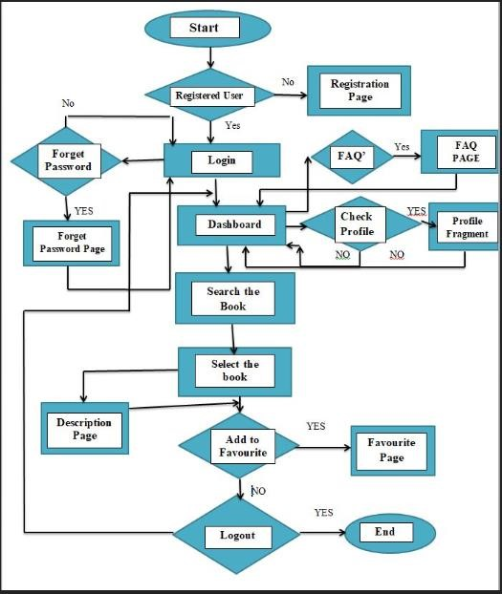

### Figure-6: Flow Chart for User

**5.1.2 Step to be followed by the user**

1. Firstly, we have build splash activity to start the application.
2. Then, we have the Login activity which consists of following steps
   * + - Register : for new User
       - Login: For existing as well as new user
       - Forgot Password: To reset your password
3. We authenticate and store the user information from the Firebase authentication.
4. After that, we made a Drawer layout of our Bookopedia app which includes various functionality
   * + - Profile Fragment: To check the profile and update the database.
       - Dashboard Fragment: Show the book on the genre basis and it is open by default.
       - Favourite: To see the favourites book that you have added or you found interesting.
       - FAQ’s Fragment: It comprises all the frequently asked questions.
       - About App : Information about the app
       - Sign-out Fragment: Remove/logout you from the app.
5. In Dashboard fragment we also include the search bar in which the user can search for the books of their interest.
6. After that list of book according to your search will appear
7. Select the book according to your choice.
8. Then the description page of the book will appear. It comprises of the following things:
   * + - Author’s Name
       - Publisher’s Name
       - Published Date
       - Languages
       - Rating
       - Price
       - Preview
9. If you want to add the book into favourites then in the description page Add to Favourites option is also given. You can see the books that are added in the favourite into navigation Drawer menu item favourites.
10. Now you can enjoy the reading of your favourite book.

**5.2 User Interface**

* + - **Login Page**

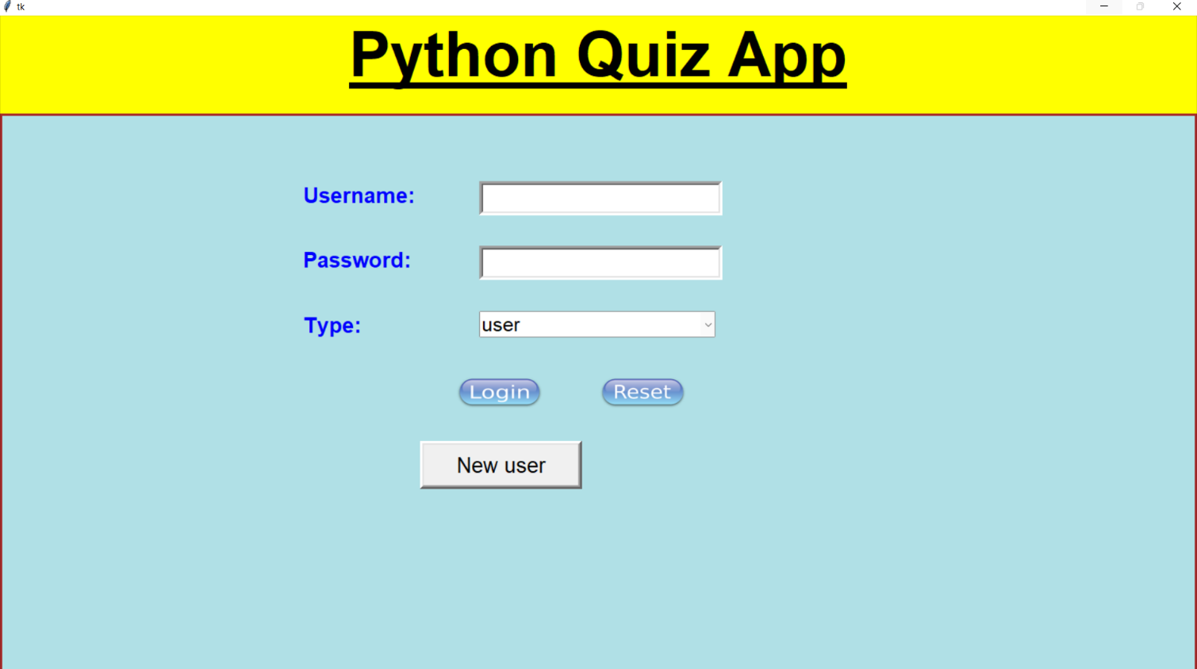

**Figure-7: Splash Screen**

* + - **Admin Page**

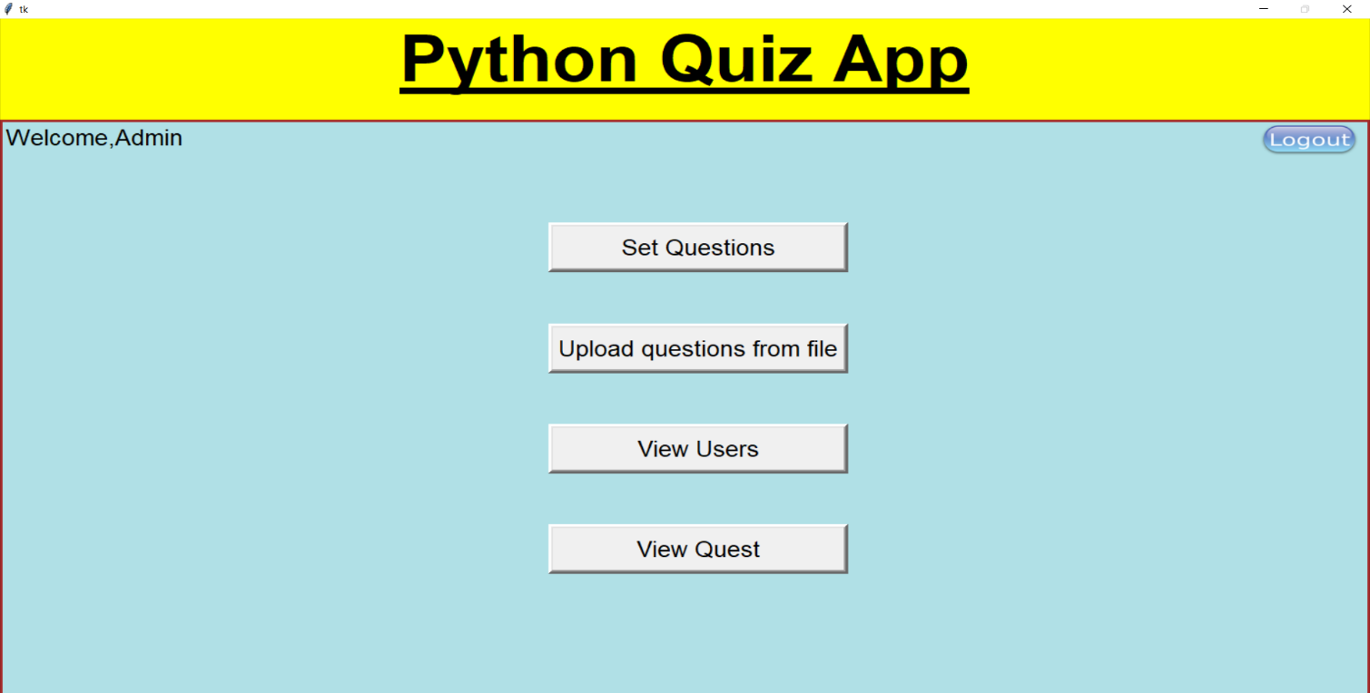

**Figure-8: Register Page**

* + - **Question Uploading Page**

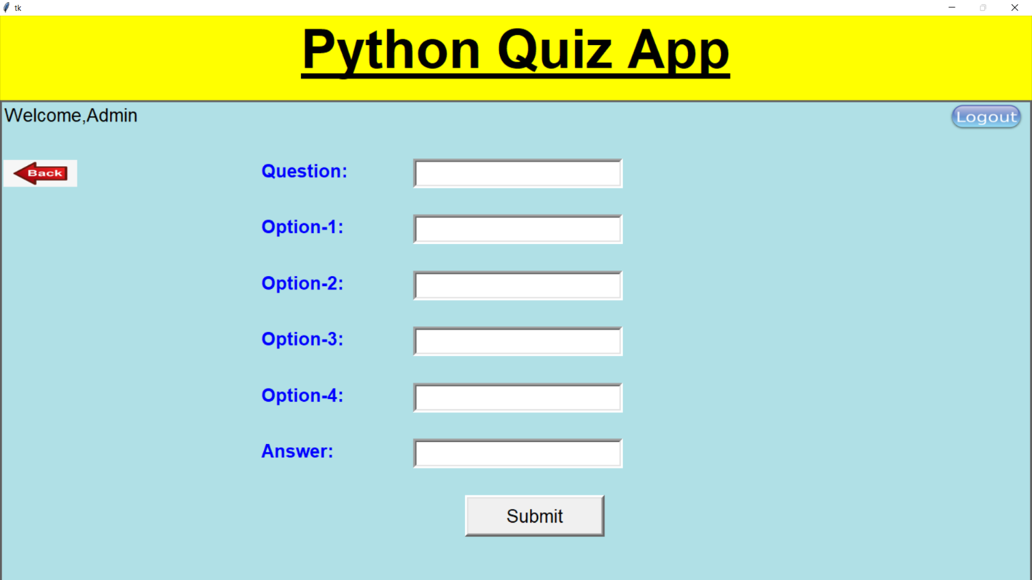

**Figure-9: Login Page**

* + - **Total Users Page**

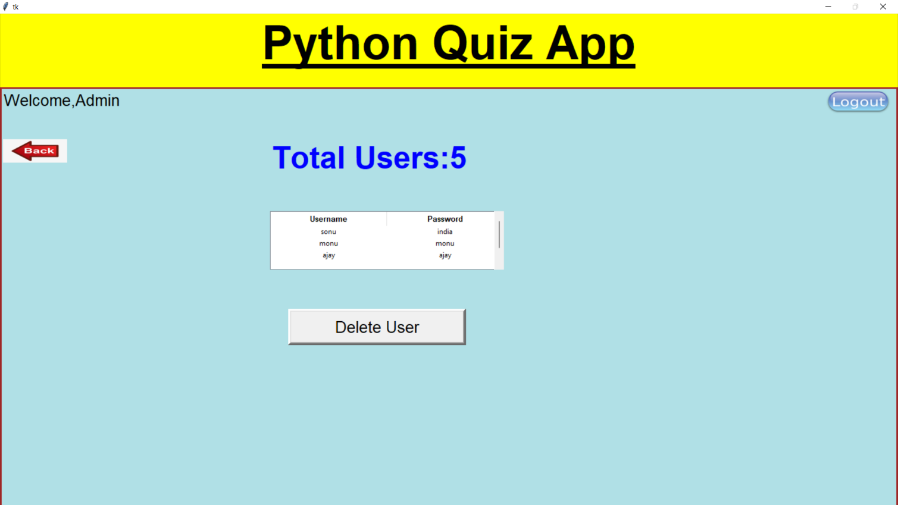

**Figure-10: Forget Password**

* + - **Question Viewing Page**

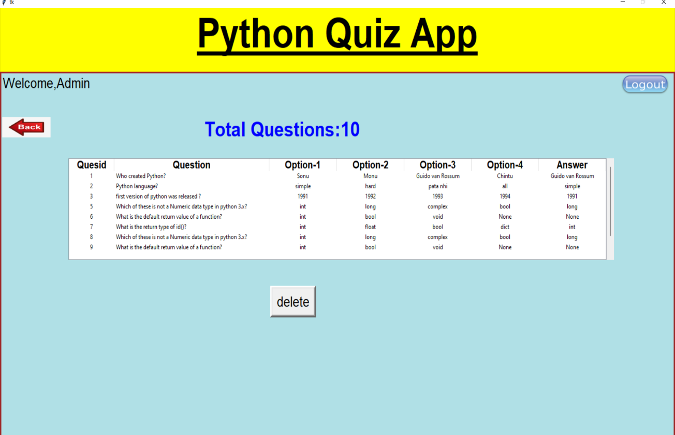

**Figure-11: Navigation Drawer**

* + - **Upload Questions for Examiner Page**

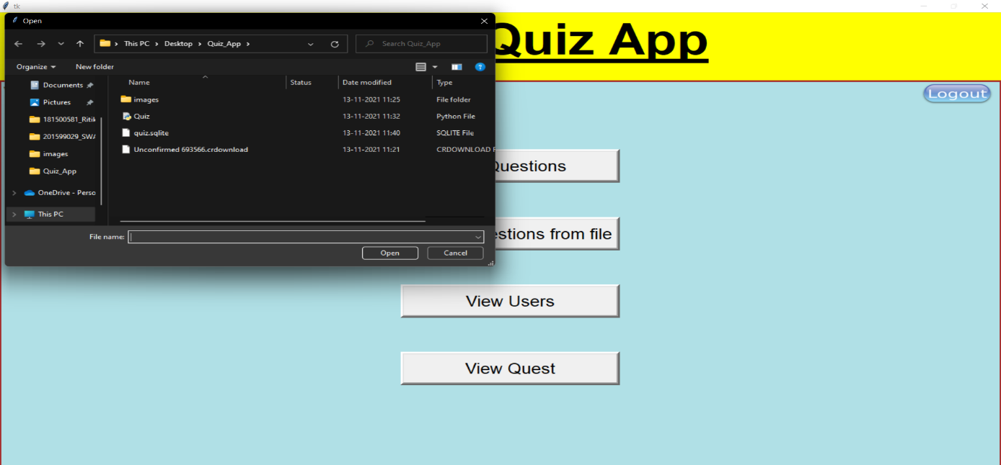

**Figure-12: Dashboard Fragment (A)**

* + - **MCQ Main Page**

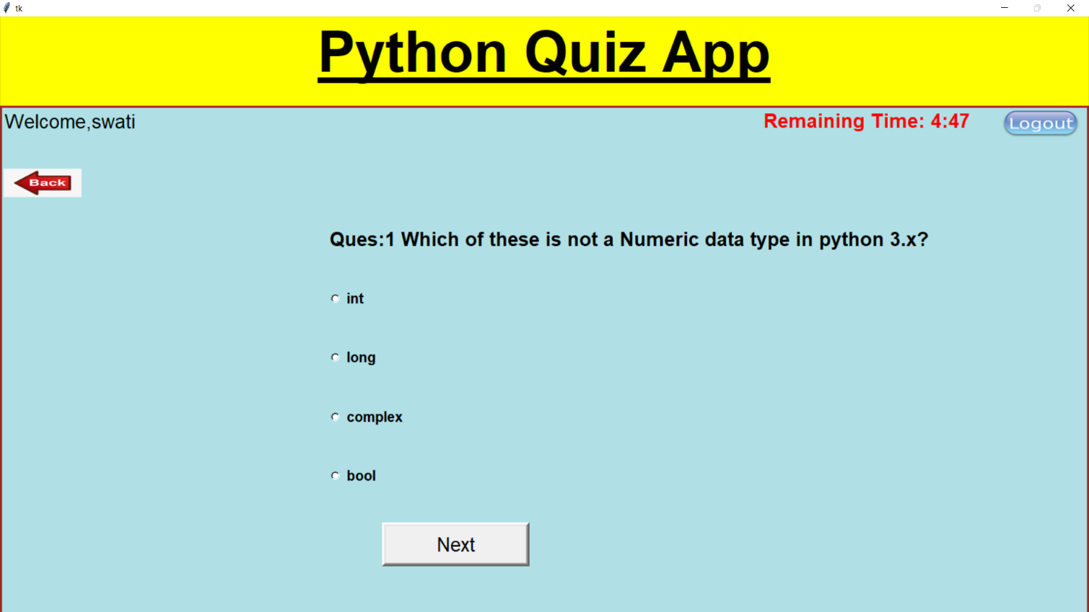

**Figure-14: Profile page**

## CHAPTER -7

**CONCLUSION**

Quizophile App is a python application that will allow users to give quiz exams easily and on different topics. It gives users the ease to perform tests and assess their knowledge level in a particular topic. It is designed in such a way that it creates interest amongst the students in the quiz exams.

This application has wide range of scope in the upcoming era. It becomes difficult and time-consuming for an examiner to make quiz exams and to check the answers manually. This application tends to remove all the problems and make examinations easy and fun.

**REFERENCES**

1. **Python Resources:**

**https://www.python.org/**